Sophie Scott
An Interactive Non-Linear Story
Homework #8a — Part 1 Submission

Where Will You Study Abroad?
Story Description
You are a student entering college, and you have the most exciting decision of the year to make! In which beautiful city would you like to study during your summer abroad trip? You start by looking at your laptop, where the application, a series of 3 seemingly simple questions, is waiting for you. Your major, your study pal, and your morning drink define your unique personality, thus determining where you stay.
There are 4 final scenarios – you find yourself studying and living in any of the 4 countries – France, the Netherlands, Brazil, or Japan. No matter what combination of answers you picked, there are numerous ways leading you to the same scenario. That makes this game a little bit different from others, because the same destination might be reached through completely different choices made by other players. All text is original, and pet illustrations are original hand-drawn artwork by me. Scene imagery is mostly photos I took, with the Netherlands photo from a free, public-domain source.
Narrative Map
The player moves through three sequential choice screens. Each choice contributes “votes” toward a destination. The country with the most votes at the end is revealed as the player’s study-abroad destination.
Step 1 — Pick Your Major
• Aviation → votes for: France, Netherlands, Brazil (+1 each)
• Political Science → votes for: Netherlands (+2), France (+1), Japan (+1)
• Theater → votes for: France (+2), Brazil (+1), Japan (+1)
• Accounting → votes for: Netherlands (+2), Brazil (+2)
Step 2 — Pick Your Pet
Original illustrations by me (higher quality in the game):
Illustration | Pet | Destination Votes
 | Frog | votes for: France (+1), Brazil (+2), Japan (+1)
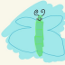 | Butterfly | votes for: Netherlands (+1), Japan (+3)
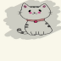 | Cat | votes for: France (+2), Brazil (+1), Japan (+1)
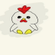 | Chicken | votes for: Netherlands (+2), Brazil (+1), Japan (+1)

Step 3 — Pick Your Drink
• Coffee → votes for: France (+2), Brazil (+1)
• Tea → votes for: Netherlands (+3), Japan (+1)
• Matcha → votes for: Japan (+4)
• Chai → votes for: Brazil (+3), Japan (+1)
Sample paths to each ending:
Major | Pet | Drink | Destination
Theater | Cat | Coffee | France
Aviation | Frog | Coffee | France
Poli Sci | Butterfly | Tea | Netherlands
Accounting | Chicken | Tea | Netherlands
Accounting | Frog | Chai | Brazil

Major | Pet | Drink | Destination
Aviation | Cat | Chai | Brazil
Theater | Butterfly | Matcha | Japan
Poli Sci | Frog | Matcha | Japan

Scene Image
(first 3 photos by me) (Netherlands photo by https://unsplash.com/s/photos/netherlands)
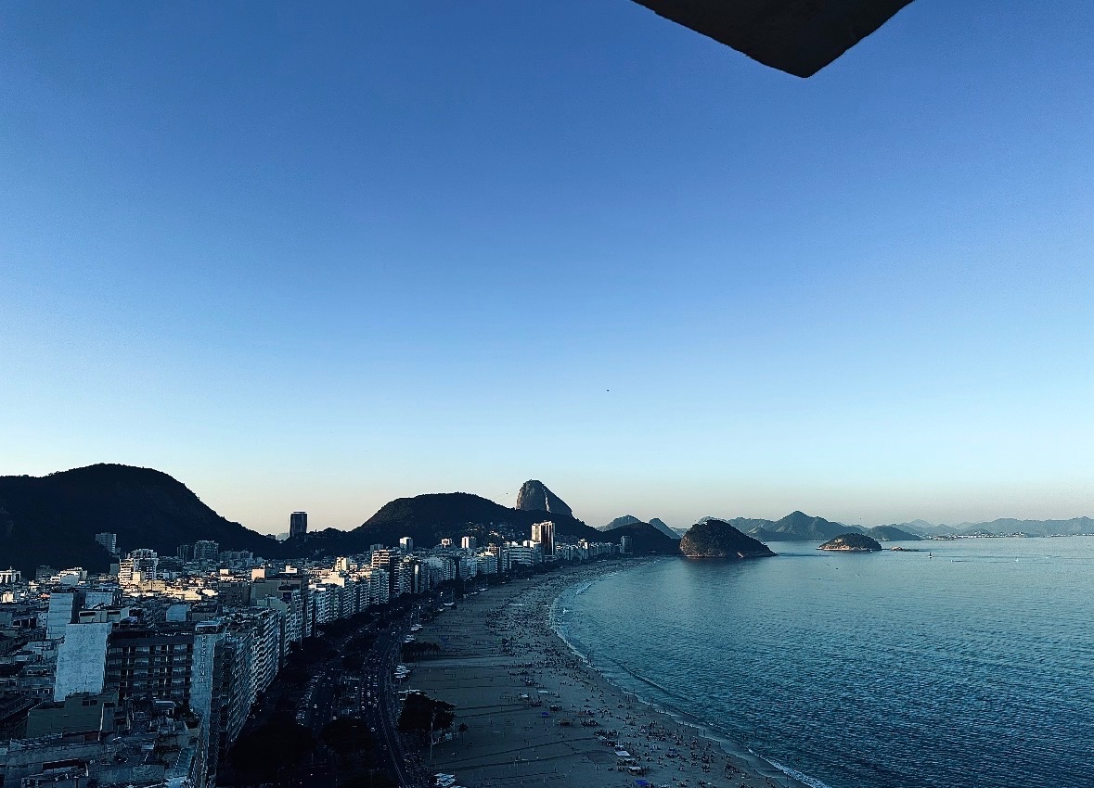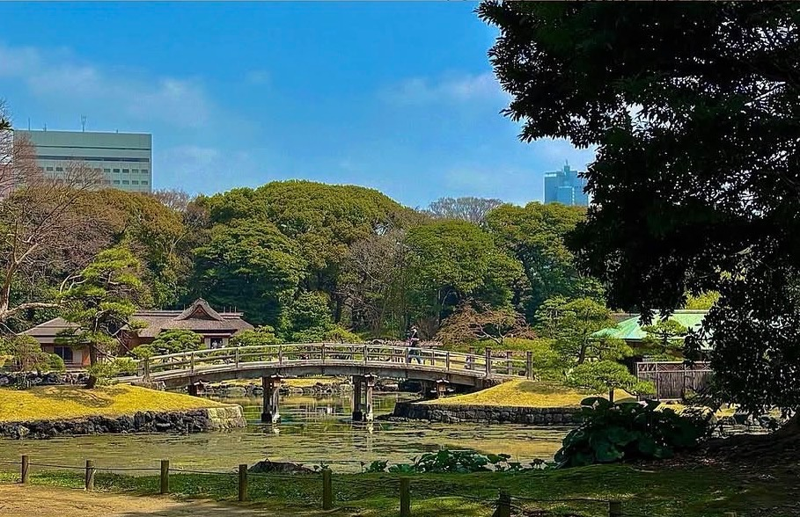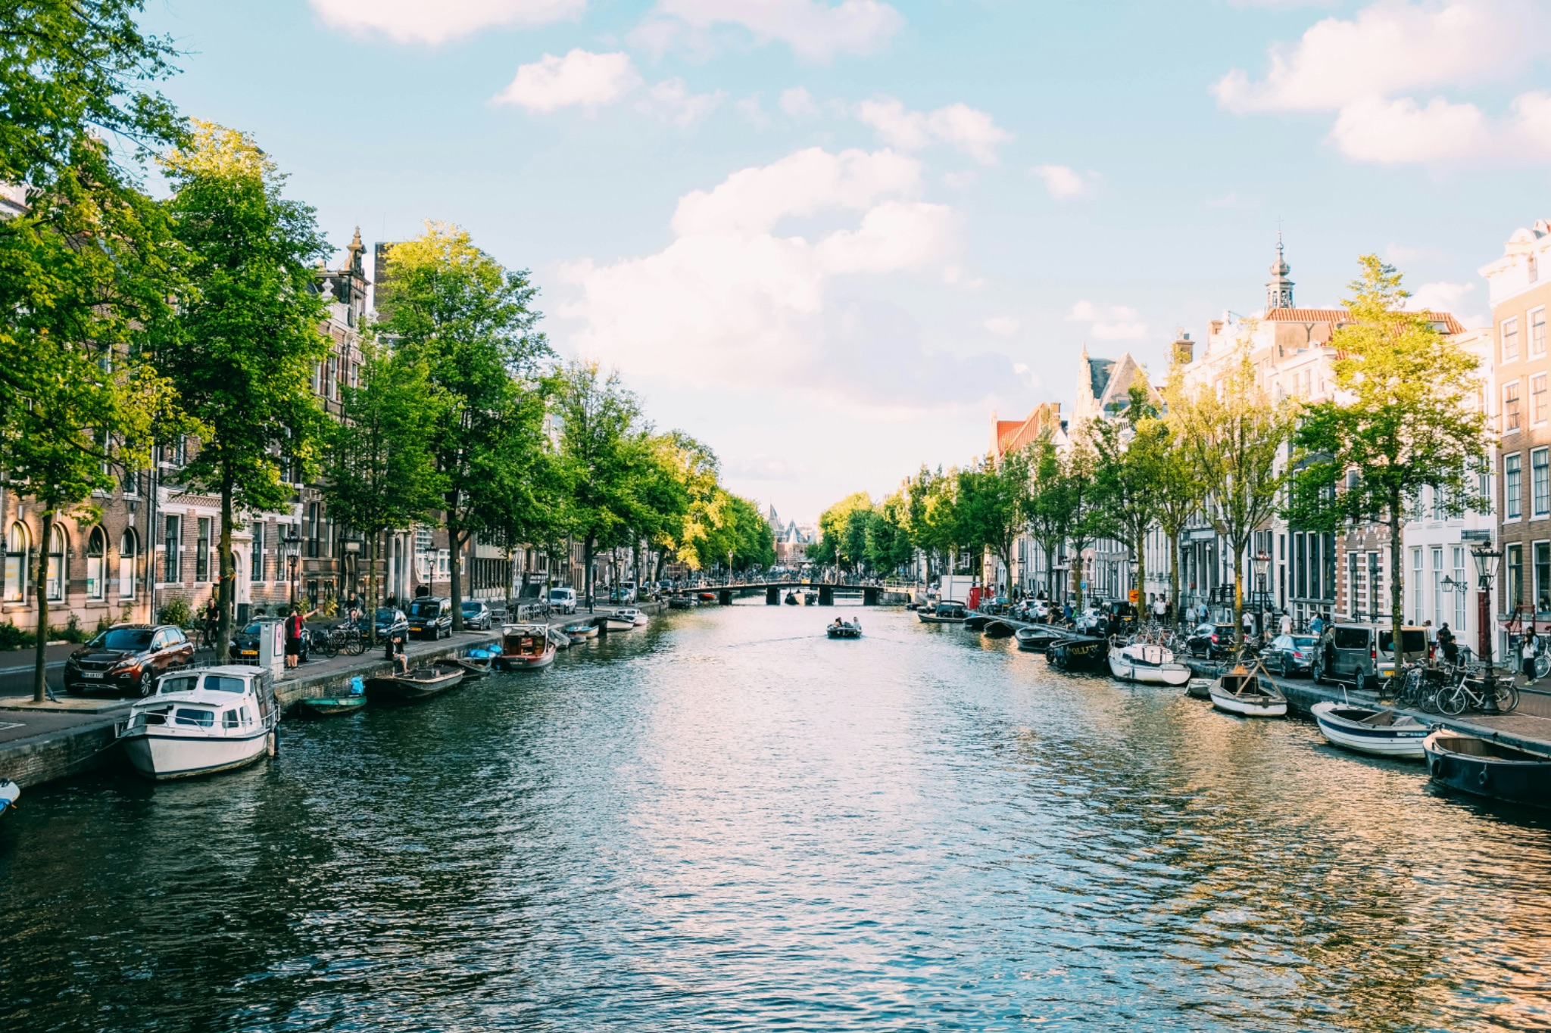
France Brazil Japan Netherlands

